Kayla Gallagher

Spring 2022

Data-Driven Journalism

Michelle Minkoff

Final Project Rough Draft

**Original Dataset:** <https://docs.google.com/spreadsheets/d/17ipWQ509ORVcZKgMW4nM249MkW8ibcDbK2rQdaVW0Fg/edit#gid=0>

**Questions:**

How did these approval ratings impact presidents running for a second term?

Is there a correlation between approval rating and political party?

How did approval ratings change throughout each presidency?

Did foreign relations like wartime, etc. have an effect on the president’s approval rating?

**Graph:**

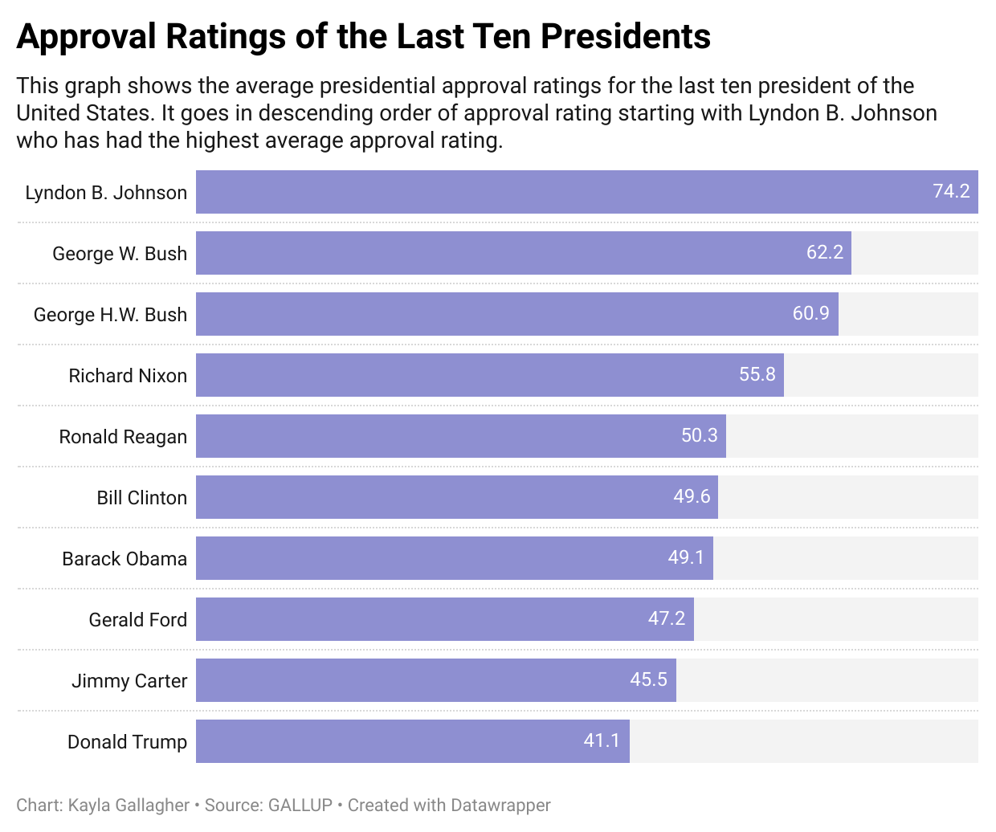

THE PRESIDENTIAL POPULARITY CONTEST

*A look into the history of presidential approval ratings and what they mean.*

The concept of presidential popularity is a simple, but powerful thing in American politics. This popularity is examined by using a presidential approval rating.

In the early 1930s, George H. Gallup, founder of the American Institute of Public Opinion released the first ever public opinion poll to get the American public’s thoughts of Franklin D. Roosevelt’s New Deal. The poll revealed that 60% of Americans thought the New Deal was going to be too expensive.

Eventually, more presidential polling was conducted to further give the public a chance to further voice their opinions on how each president was doing. The basic question of presidential approval ratings is: “Do you approve or disapprove of the way [insert President’s name here] is handling their job as president?” [according to TIME](https://time.com/5511118/presidential-approval-ratings-history/).

There are a number of factors that are taken into account when calculating a president’s approval rating like the national unemployment rates and the state of the economy during their presidency. However, much remains to be seen about the direct impact of these numbers.

This analyzed data set looks at the last ten presidents of the United States and observes the average approval ratings of each and whether or not they had a direct impact on re-election, if the president chose to run for a second term, whether or not political party has any impact on these numbers and if they truly matter to the people.

Out of the last ten presidents who have served the nation, Lyndon B. Johnson has the highest average approval rating of 74.2%.Johnson’s presidency began after the assassination of President John F. Kennedy, leaving the vice president to serve one partial term before he was re-elected for a second term.

The president with the lowest approval rating over the last ten presidents was the 45th president of the United States, Donald Trump with an average rating of 41.1%. Despite his controversial presidency, Trump had the second lowest unemployment rate at 5.04% after Johnson. However, Trump also had the lowest Gross Domestic Product (GDP) growth with an average of 1% during the course of his presidency.

FormerPresident George W. Bush has also seen high approval ratings from the nation at 60.9%. However, Bush hit a record-high approval rating of 80% shortly after the terrorist attacks on the Twin Towers in New York on Sept. 11, 2001.

Four out of the last ten United States presidents have been Democrats, with the other six as Republicans.Out of these presidents, two have been impeached: Bill Clinton and Donald Trump. Clinton’s impeachment followed the Monica Lewinsky scandal and Trump was impeached twice during his four-year term. Richard Nixon faced potential impeachment after the Watergate scandal, but resigned early into his second term before it could happen.

Due to the situation in which Johnson became president, data shows that his political statistics led to him having the highest approval rating. During his almost 2-term presidency he had the lowest average unemployment rate at 4.18% and the highest GDP growth at 5.3%.

These numbers can contain important stakes for presidents in office. Some presidents have lost Congressional seats for their parties due to low approval ratings.

Although these numbers and percentages may help contribute, some presidential popularity experts say that it is really just about general perception and the mood of the country.